Final Case Analysis: Lending Club (2012–2017)
Course: Data Science Tools
Student: Siddhesh Aher
Institution: New England College
1. Introduction
Lending Club is a leading peer-to-peer online lending marketplace that connects individual borrowers with investors. Founded in 2007, the company specializes in short-term personal loans of up to $40,000, although it offers other financial products as well. Lending Club significantly changed its business model after its Initial Public Offering (IPO) in December 2014, expanding loan issuance and adopting a more aggressive lending strategy. This shift resulted in a sharp increase in loan volume but also raised concerns regarding lending risk and credit quality.
This case study analyzes Lending Club’s personal loan data from 2012 through 2017 using R programming. The goal of the analysis is to examine geographic lending patterns, loan characteristics, borrower attributes, and trends over time. In addition to loan-level data, the analysis incorporates U.S. state demographic data and regional classifications to provide broader economic and geographic context. The findings are presented through both statistical analysis and visualizations to identify meaningful patterns and relationships within the data.

2. Data Description
The primary dataset consists of six Lending Club CSV files corresponding to the years 2012 through 2017. Each file contains approximately 31 variables, including loan amount, interest rate, loan grade, borrower income, employment length, loan issue date, and borrower state. File sizes increase substantially after 2015, reflecting Lending Club’s post-IPO expansion.
Two supplemental datasets are used:
- states.csv – Contains state-level demographic characteristics such as population size and median household income.
- states_regions.csv – Categorizes each state into its respective U.S. region and division.
All datasets were cleaned, standardized, and merged to form one comprehensive analytical dataset.

3. Data Merging and Cleaning
The six Lending Club files were stacked vertically to create a unified dataset containing all loans issued between 2012 and 2017. Column names were standardized using clean_names() to ensure consistency. Because some numeric variables were stored as character strings, all numeric fields were carefully converted to numeric types after cleaning corrupted or duplicated header rows.
State abbreviations in the Lending Club data were standardized by trimming whitespace and converting values to uppercase. These abbreviations were then mapped to full state names to allow accurate merging with the demographic and regional datasets. The combined dataset was created by merging Lending Club loan data with state demographic data and regional classifications.
Observations with missing population data were removed to ensure accurate per-capita calculations. This cleaning process resulted in a robust dataset suitable for geographic, temporal, and financial analysis.

4. Analysis
Loans by State
The distribution of loans varies significantly by state. Large, populous states such as California, Texas, New York, and Florida account for the highest number of loans. This pattern is expected, as these states have larger populations and greater access to financial services.
Smaller or less populous states show substantially fewer loans, indicating lower participation or reduced access to Lending Club’s platform.
 | state_full | num_loans
1 | California | 91928
2 | Texas | 57030
3 | New York | 54645
4 | Florida | 46859
5 | New Jersey | 26093

Loans per Capita
When adjusting for population size, the distribution changes. Several mid-sized states show relatively high loans per capita, suggesting stronger adoption of online lending platforms relative to population. This indicates that population size alone does not fully explain loan distribution.
state_full | population | num_loans | loans_per_capita
Alabama | 4850771 | 8494 | 0.0017511
Alaska | 738565 | 1614 | 0.0021853
Arizona | 6809946 | 16029 | 0.0023538
Arkansas | 2977944 | 4980 | 0.0016723
California | 38982847 | 91928 | 0.0023582

Regional and Divisional Trends
At the regional level, the South and West regions account for the largest share of loans, followed by the Midwest and Northeast. Divisional analysis shows higher loan volumes in economically diverse and densely populated divisions such as the Pacific and South Atlantic.
 | region | num_loans
1 | Midwest | 115685
2 | Northeast | 140046
3 | South | 241964
4 | West | 169072

Missing States
Certain states are missing from the Lending Club dataset. These omissions are due to Lending Club’s lending restrictions and regulatory limitations in those states during the study period.

Below are the states that are missing.
- "District of Columbia"
- "Puerto Rico"

Average Loan Amount by State and Division
The average loan amount varies considerably across states and divisions. States with higher costs of living and higher median incomes such as California, New York, and Massachusetts tend to have higher average loan amounts. In contrast, states with lower income levels generally show smaller average loan sizes.
At the divisional level, the Pacific and New England divisions exhibit higher average loan amounts, while divisions in the Midwest and parts of the South show lower averages. This reflects differences in income levels, borrowing needs, and cost-of-living variations.
Average Loan Amount by State:
state_full | avg_loan_amount
Alabama | 14316.19
Alaska | 16891.93
Arizona | 14442.01
Arkansas | 13804.85
California | 15069.7

Average Loan Amount by Division:
 | division | avg_loan_amount
1 | East North Central | 14423.2
2 | East South Central | 14326.54
3 | Middle Atlantic | 14881.02
4 | Mountain | 14578.36
5 | New England | 15088.84

Loan Grade, Interest Rates, and Loan Amounts
Loan grade plays a critical role in determining both interest rates and loan amounts. Higher-quality grades (A and B) are associated with lower interest rates and slightly higher loan amounts. As loan grades decline, interest rates increase significantly, reflecting higher perceived credit risk.
Lower-grade loans (E, F, and G) exhibit much higher interest rates but do not necessarily correspond to larger loan amounts. This suggests that Lending Club mitigates risk by charging higher interest rather than increasing exposure through higher loan values.
 | grade | avg_interest | avg_loan_amount | count
1 | A | 7.187254 | 14056.75 | 89430
2 | B | 10.591477 | 13245.25 | 199663
3 | C | 13.925127 | 14641.03 | 203226
4 | D | 17.527182 | 15855.04 | 102764
5 | E | 20.765849 | 18285.48 | 50370
6 | F | 24.626025 | 19858.57 | 16986
7 | G | 27.276915 | 21116.4 | 4328

Trends Over Time (2012–2017)
A year-by-year analysis reveals a clear increase in the number of loans issued over time, particularly after 2014. This trend aligns with Lending Club’s IPO and subsequent business expansion.
Average loan amounts also increase modestly over time, indicating growing borrower confidence and potentially rising borrowing needs. Interest rates fluctuate slightly but generally remain higher in later years, possibly reflecting a shift toward more riskier borrowers as Lending Club expanded its market.

 | state | issue_year | loans | avg_amount | avg_interest
1 | AK | 2012 | 88 | 16343.47 | 16.2275
2 | AK | 2013 | 170 | 17032.35 | 15.01524
3 | AK | 2014 | 293 | 16791.55 | 14.50833
4 | AK | 2015 | 494 | 17402.53 | 13.2436
5 | AK | 2016 | 375 | 16278.73 | 13.34251
6 | AK | 2017 | 194 | 17054.38 | 14.01268

Population, Income, and Lending Relationships
Population vs. Average Loan Amount
A weak positive correlation exists between state population size and average loan amount. While more populous states issue more loans overall, population alone does not strongly predict loan size. Other economic factors, such as income and cost of living, appear to play a larger role.

 | state | population | avg_loan
1 | AK | 738565 | 16891.93
2 | AL | 4850771 | 14316.19
3 | AR | 2977944 | 13804.85
4 | AZ | 6809946 | 14442.01
5 | CA | 38982847 | 15069.7
6 | CO | 5436519 | 14896.4

Loan Grade and Median Income
States with higher median household incomes tend to have a higher proportion of better-quality loan grades. This suggests that borrowers in wealthier states are generally less risky and qualify for lower interest rates. Conversely, states with lower median incomes show a greater concentration of lower-grade loans.

 | state | grade | num_loans | median_income_households
1 | MD | A | 2184 | 78916
2 | MD | B | 4971 | 78916
3 | MD | C | 5152 | 78916
4 | MD | D | 2654 | 78916
5 | MD | E | 1422 | 78916
6 | MD | F | 465 | 78916

5. Visualization AnalysisFigure 1
Interest Rate Distribution by Loan Grade

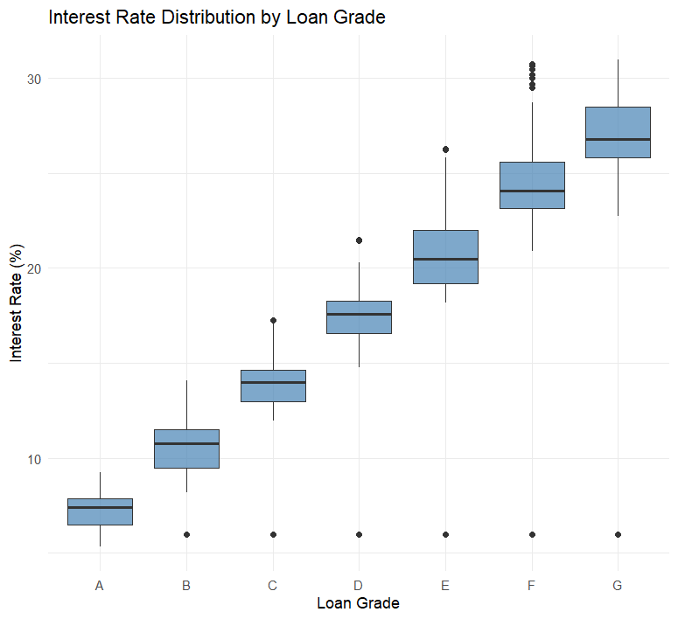
Note. Boxplots illustrate increasing interest rates as loan grade decreases.
Figure 2
Average Lending Club Loan Amount by State (2012–2017)

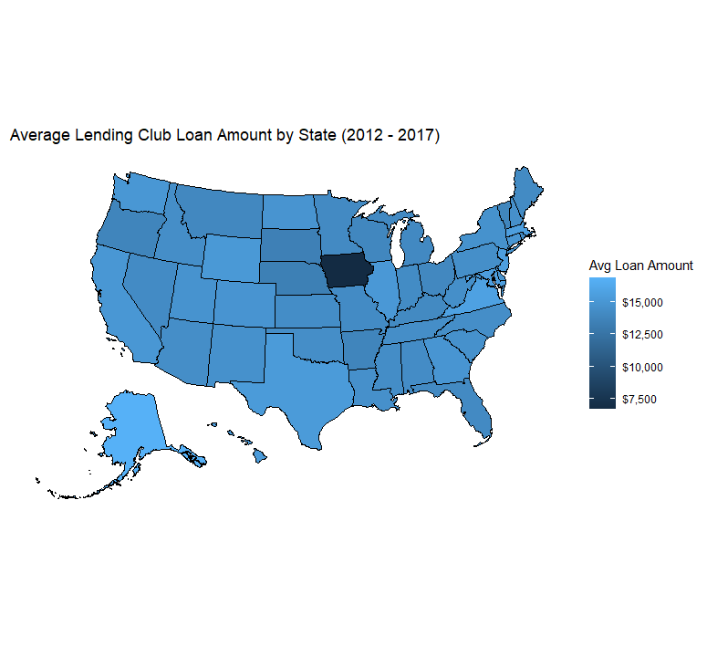
Note. Darker shades represent higher average loan amounts.
Figure 3
Relationship Between Annual Income and Loan Amount
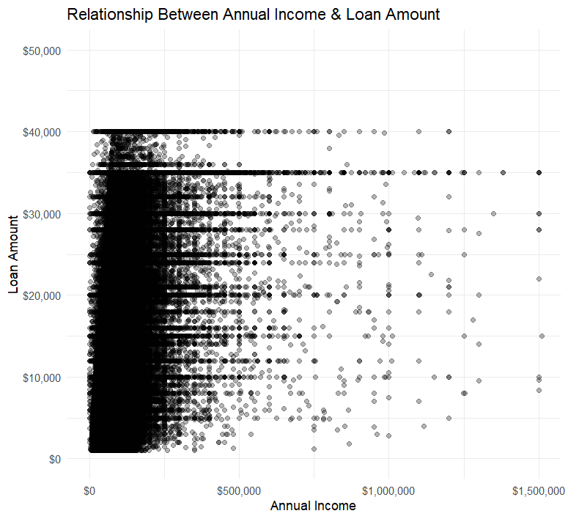
Figure 4
Employment Length Versus Loan Amount
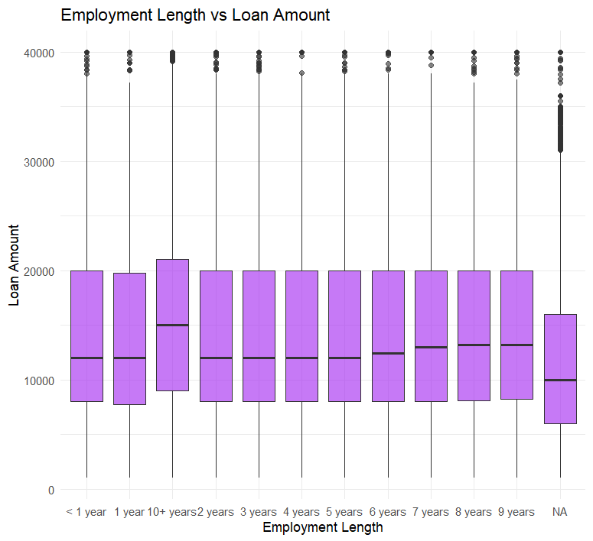
Figure 5
Average Interest Rate by U.S. Region
